**Part 3: Assembly of Colour Sensor PCB**

Parts: 1 x TCRT5000 sensor, 1 x 10kOhm resistor, 1 x 220 Ohm resistor and

1 x DIT_RS_CS5 PCB

1 x 6mm M3 Hex Standoff, 1 x 6mm M3 Hex nut, 1 x 6mm M3 Hex screw and 1 x Washer all made from Nylon.

Wires: 1 x Long Red Wire, 1 x Long Blue Wire and 1 x **Long Black Wire**.

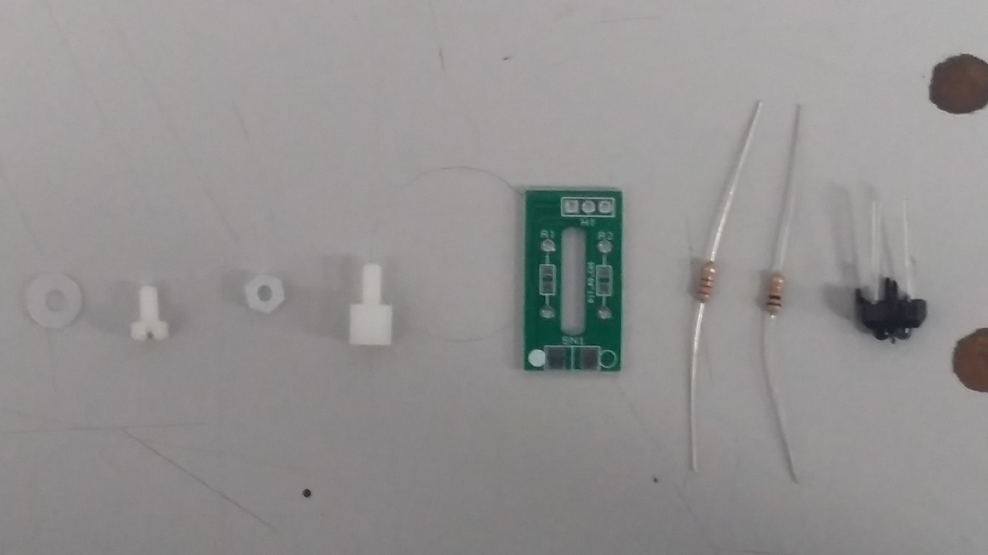

Take the PCB and insert (from the underside of the PCB) the 10K resistor into the location marked R1. Do the same with the 220 Ohm resistor for the R2 location. Solder both onto the board. See below.

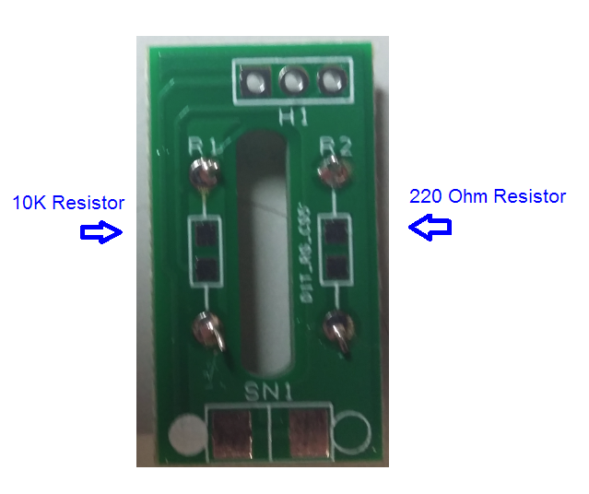

Place the TCRT 5000 Sensor such that the DARK LED on the sensor is on the same side as the filled white circle on the PCB board. See below. Solder into position for both front and back pins.

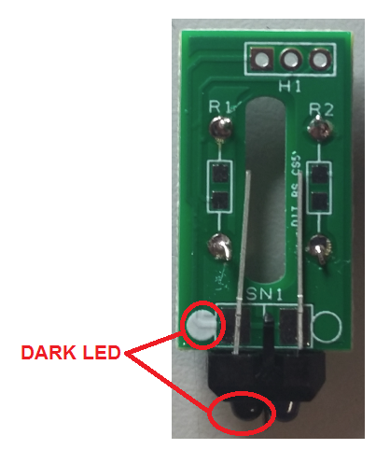

Cut the legs of the sensor once they have been soldered into position.

Place the Long Red wire into Pin 1 (Square Pad), the Long Blue wire into Pin 2 and the **Long Black** wire into Pin 3 of the H1 block. Solder into position. See below.

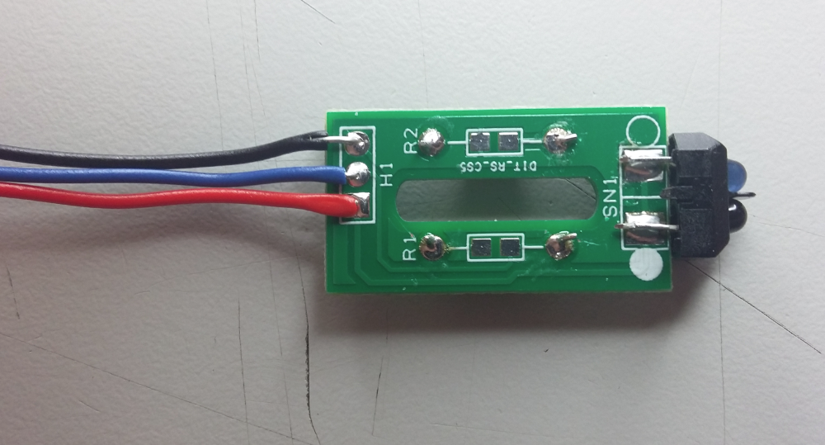

Take the Hex Standoff and secure to the PCB using the 6mm Nylon screw. Place the plastic washer onto the other end of the Standoff and secure with the Hex Nut. See below.

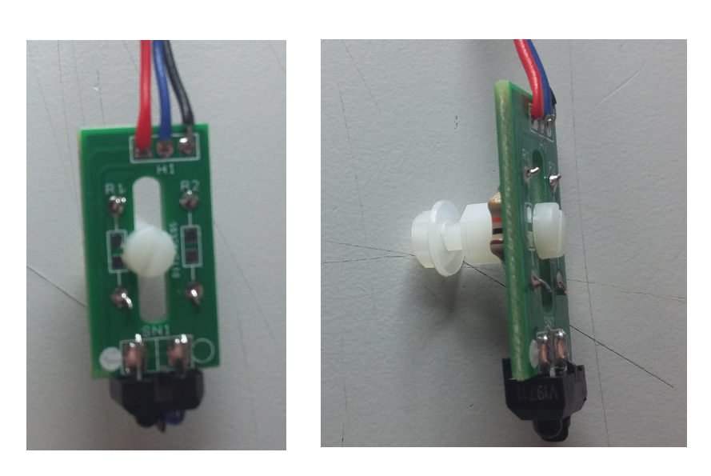

The sensor assembly is now complete and ready for mounting.